WSA - HW – 7 :

1. Describe the idea of the Group Policy feature. Try to find any non-Microsoft softwares that provide Group Policy Administrative Templates.

The idea of the Group Policy feature:

In Windows 2000, administrators use Group Policy to enhance and control users' desktops. To simplify the process, administrators can create a specific desktop configuration that is applied to groups of users and computers. The Windows 2000 Active Directory™ service enables Group Policy. The policy information is stored in Group Policy objects (GPOs), which are linked to selected Active Directory containers: sites, domains, and organizational units (OUs).
A GPO can be used to filter objects based on security group membership, which allows administrators to manage computers and users in either a centralized or a de-centralized manner. To do this, administrators can use filtering based on security groups to define the scope of Group Policy management, so that Group Policy can be applied centrally at the domain level, or in a decentralized manner at the OU level, and can then be filtered again by security groups. Administrators can use security groups in Group Policy to:
Filter the scope of a GPO. This defines which groups of users and computers a GPO affects.
Delegate control of a GPO. There are two aspects to managing and delegating Group Policy: managing the group policy links and managing who can create and edit GPOs.
Administrators use the Group Policy Microsoft Management Console (MMC) snap-in to manage policy settings. Group Policy includes various features for managing these policy settings. In addition, third parties can extend Group Policy to host other policy settings. The data generated by Group Policy is stored in a Group Policy object (GPO), which is replicated in all domain controllers within a single domain.
The Group Policy snap-in includes several MMC snap-in extensions, which constitute the main nodes in the Group Policy snap-in. The extensions are as follows:
Administrative templates. These include registry-based Group Policy, which you use to mandate registry settings that govern the behavior and appearance of the desktop, including the operating system components and applications.
Security settings. You use the Security Settings extension to set security options for computers and users within the scope of a Group Policy object. You can define local computer, domain, and network security settings.
Software installation. You can use the Software Installation snap-in to centrally manage software in your organization. You can assign and publish software to users and assign software to computers.
Scripts. You can use scripts to automate computer startup and shutdown and user logon and logoff. You can use any language supported by Windows Script Host. These include the Microsoft Visual Basic® development system, Scripting Edition (VBScript); JavaScript; PERL; and MS-DOS®-style batch files (.bat and .cmd).
Remote Installation Services. You use Remote Installation Services (RIS) to control the behavior of the Remote Operating System Installation feature as displayed to client computers.
Internet Explorer maintenance. You use Internet Explorer Maintenance to manage and customize Microsoft® Internet Explorer on Windows 2000-based computers.
Folder redirection. You use Folder Redirection to redirect Windows 2000 special folders from their default user profile location to an alternate location on the network. These special folders include My Documents, Application Data, Desktop, and the Start Menu.
Figure 1 below shows how Group Policy objects use the Active Directory hierarchy for deploying Group Policy.
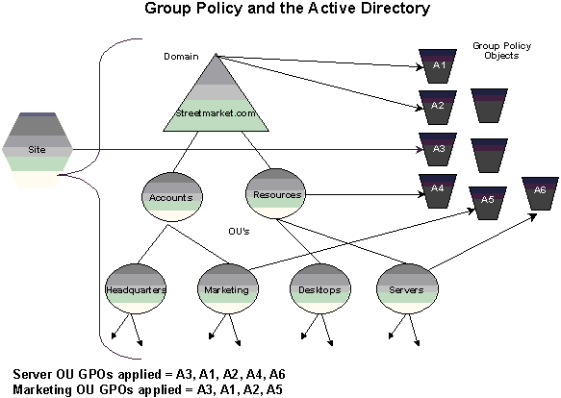
Figure 1: The Hierarchy of Group Policy and the Active Directory
Group Policy objects are linked to site, domain, and OU containers in the Active Directory. The default order of precedence follows the hierarchical nature of the Active Directory: sites are first, then domains, and then each OU. A GPO can be associated with more than one Active Directory container or multiple containers can be linked to a single GPO.
Non-Microsoft softwares that provide Group Policy Administrative Templates:

Product sites:

- http://www.quest.com/gpoadmin
- http://www.condreycorp.com/groupsymmetry
- http://www.youtube.com/watch?v=tIUCQbmL12E
- http://www.novell.com/products/zenworks
- http://www.condreycorp.com/fsf
- http://www.windowsecurity.com/software/Group-Policy-Management/
- http://documents.software.dell.com/book/2377
- http://documents.software.dell.com/DOC154810

